2018 MEETING ROOM REQUEST FORM
Name of Organization:
Contact Person:
Email:
Phone Number:
Title of Meeting:
Meeting Date(s):
Meeting Start and Finish Times:
Would you like your meeting posted on the hotel event monitors?
Number of People attending:
Audio Visual Needs:
(Additional Expense to be paid directly to the hotel)
Food & Beverage Needs:
(Additional Expense to be paid directly to the hotel)
Room Set-Up:
Classroom (with tables) | Theater (chairs only) | Hollow Square
U-Shaped | Rounds | Fishbone
 |  | 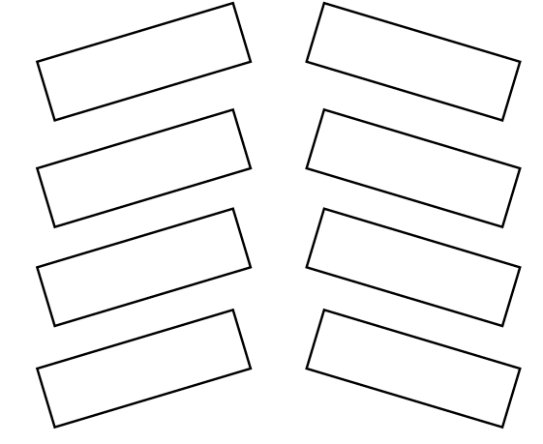
Additional Information/Special Instructions:

Please send all meeting room requests to Mary Lembke at marylembke@maryforlife.org.

Notes: Because there are many groups requesting space and a limited amount of meeting rooms available, space will be assigned on a first come, first served basis. Since we often must shift room assignments, we urge you not to publicize the room name, but rather “Please check Event Monitors for Room Name.”

